CSA1715-ARTIFICIAL INTELLIGENCE
LAB PROGRAM-7
14-07-2026
7. Write the python program to implement BFS.

Aim
To write a Python program to implement the Breadth-First Search (BFS) algorithm for graph traversal using user input.

Algorithm
- Read the number of vertices from the user.
- Read each vertex and its adjacent vertices to construct the graph as an adjacency list.
- Read the starting vertex for traversal.
- Initialize an empty visited set and a queue containing the starting vertex.
- Remove the front vertex from the queue.
- If the vertex has not been visited, display it and mark it as visited.
- Add all unvisited adjacent vertices of the current vertex to the queue.
- Repeat Steps 5–7 until the queue becomes empty.
Program
from collections import deque

graph = {}

n = int(input("Enter number of vertices: "))

for i in range(n):
v = input("Enter vertex: ")
adj = input("Enter adjacent vertices (space separated): ").split()
graph[v] = adj

start = input("Enter starting vertex: ")

visited = set()
q = deque([start])

print("BFS Traversal:")

while q:
node = q.popleft()
if node not in visited:
print(node, end=" ")
visited.add(node)
for i in graph[node]:
if i not in visited:
q.append(i)

Input
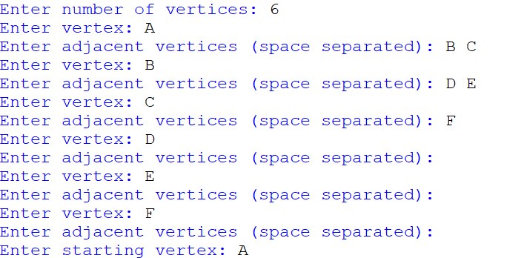

Output
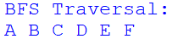
Result:
Thus, the Python program to implement the Breadth-First Search (BFS) algorithm using user input was executed successfully, and the graph was traversed in BFS order with the desired output obtained.

